ICL00100 – REQUEST Lookup

USER INTERFACE

INITIAL VERSION
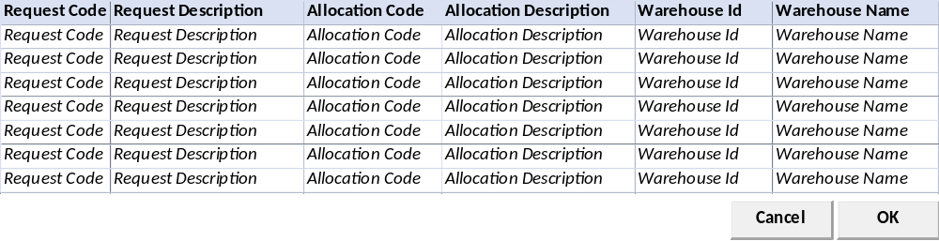

BUTTON DEFINITION
Button Name | Action
Cancel | Jalankan CANCEL PROCESS
OK | Jalankan PROCESS

INPUT PARAMETER
Parameter Name | Description
CCOMPANY_ID | Company Id
CPROPERTY_ID | Property Id
CDEPT_CODE | Selected Dept Code
CUSER_ID | User Id

OUTPUT PARAMETER
Parameter Name | Description
CCOMPANY_ID | Company Id
CPROPERTY_ID | Property Id
CREQUEST_CODE | Request Code
CREQUEST_NAME | Request Description
CALLOC_ID | Allocation Id
CALLOC_NAME | Allocation Name
CWAREHOUSE_CODE | Warehouse Code
CWAREHOUSE_NAME | Warehouse Name

INITIAL PROCESS
Test
- Load data from Input Parameter
- Set VAR_COMPANY_ID = Login User’s company id
- Set VAR_PROPERTY_ID = Selected Property Id
- Set VAR_DEPT_ID = Selected Property Id
- Set VAR_USER_ID = Login User Id

- Load Request List
Jalankan RSP_IC_GET_REQUEST_LIST dengan parameter, simpan hasil ke VAR_REQUEST_LIST
  - VAR_COMPANY_ID
  - CPROPERTY_ID
  - VAR_DEPT_ID
  - VAR_USER_ID

DISPLAY PROCESS

FIELD DEFINITION
Name | Field | Type | Validation
Request Code | CREQUEST_CODE | Textbox, Disabled
Request Description | CREQUEST_NAME | Textbox, Disabled
Allocation Id | CALLOC_ID | Textbox, Disabled
Allocation Name | CALLOC_NAME | Textbox, Disabled
Warehouse Code | CWAREHOUSE_CODE | Textbox, Disabled
Warehouse Name | CWAREHOUSE_NAME | Textbox, Disabled

CANCEL PROCESS

VALIDATION
Field | Condition | Validation Message

ACTION
- Close this Lookup

PROCESS

VALIDATION
Field | Condition | Validation Message

ACTION
- Close this Lookup
- Return VAR_SELECTED_REQUEST ke form pemanggil

SELECT DATA PROCESS

VALIDATION
Field | Condition | Validation Message

ACTION
- Close this Lookup
- Return VAR_SELECTED_PRICELIST_HEADER ke form pemanggil

ICL00200 – REQUEST No Lookup

USER INTERFACE

INITIAL VERSION
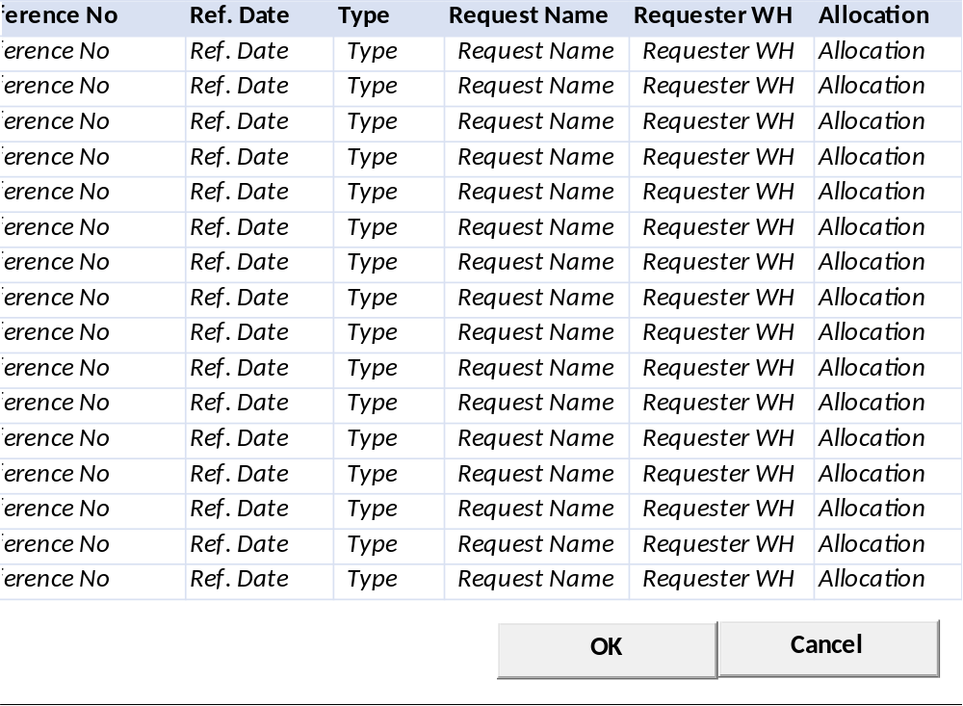

BUTTON DEFINITION
Button Name | Action
Cancel | Jalankan CANCEL PROCESS
OK | Jalankan PROCESS

INPUT PARAMETER
Parameter Name | Description
CCOMPANY_ID | Company Id
CPROPERTY_ID | Property Id
CDEPT_CODE | Selected Dept Code
CALLOCATION_ID | Selected Allocation Id
CUSER_ID | User Id

OUTPUT PARAMETER
Parameter Name | Description
CCOMPANY_ID | Company Id
CPROPERTY_ID | Property Id
CREF_NO | Ref No
CREF_DATE | Ref Date
CTYPE_DESCR | Type
CREQUEST_NAME | Request Name
CREQ_WAREHOUSE_DESCR | Requester WH
CALLOC_NAME | Allocation

INITIAL PROCESS
Test
- Load data from Input Parameter
- Set VAR_COMPANY_ID = Login User’s company id
- Set VAR_PROPERTY_ID = Selected Property Id
- Set VAR_DEPT_ID = Selected Property Id
- Set VAR_ALLOC_ID = Selected Allocation Id
- Set VAR_USER_ID = Login User Id

- Load Request List
Jalankan RSP_IC_GET_INVENTORY_REQ_LIST dengan parameter, simpan hasil ke VAR_REQUEST_NO_LIST
  - VAR_COMPANY_ID
  - CPROPERTY_ID
  - VAR_DEPT_ID
  - VAR_ALLOC_ID
  - VAR_USER_ID

DISPLAY PROCESS

FIELD DEFINITION
Name | Field | Type | Validation
Ref No | CREF_NO | Textbox, Disabled
Ref Date | CREF_DATE | Textbox, Disabled
Type | CTYPE_DESCR | Textbox, Disabled
Request Name | CREQUEST_NAME | Textbox, Disabled
Requester WH | CREQ_WAREHOUSE_DESCR | Textbox, Disabled
Allocation | CALLOC_NAME | Textbox, Disabled

CANCEL PROCESS

VALIDATION
Field | Condition | Validation Message

ACTION
- Close this Lookup

PROCESS

VALIDATION
Field | Condition | Validation Message

ACTION
- Close this Lookup
- Return VAR_SELECTED_REQUEST_NO ke form pemanggil

SELECT DATA PROCESS

VALIDATION
Field | Condition | Validation Message

ACTION
- Close this Lookup
- Return VAR_SELECTED_REQUEST_NO ke form pemanggil

ICL00300 – IC TRANSACTION LOOKUP

USER INTERFACE

INITIAL VERSION
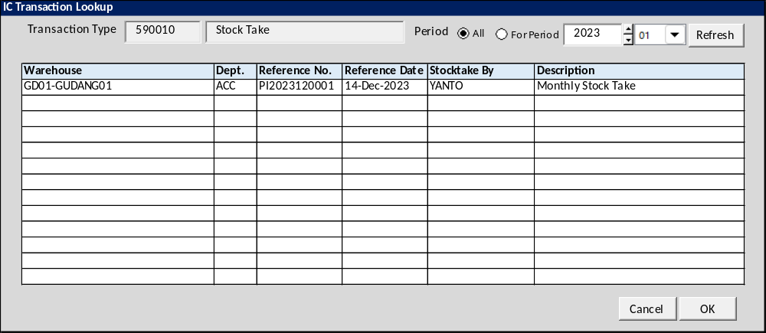

BUTTON DEFINITION
Button Name | Action
Refresh | Jalankan REFRESH PROCESS
OK | Jalankan SELECT DATA PROCESS
Cancel | Tutup Form

INPUT PARAMETER
Parameter Name | Description
CCOMPANY_ID | Company ID
CPROPERTY_ID | Property ID
CTRANS_CODE | Transaction Code
CPERIOD | Period
CDEPT_CODE | Department Code
CWAREHOUSE_ID | Warehouse Id
CALLOC_ID | Alloc Id
CTRANS_STATUS | Transaction Status(ex:00,10,20)
CTRANS_NAME | Transaction Name
CLANGUAGE_ID | Language ID

OUTPUT PARAMETER
Parameter Name | Description
CREC_ID | Record Id
CCOMPANY_ID | CompanyI Id
CPROPERTY_ID | Property Id
CDEPT_CODE | Department Code
CDEPT_NAME | Department Name
CTRANS_CODE | Transaction Code
CREF_NO | Reference No
CTRANS_STATUS | Transaction Status
CSTATUS | Transaction Status Name
CSTOCKTAKE_BY | Stocktake By
CWAREHOUSE_ID | Customer ID
CWAREHOUSE_NAME | Customer Name
CTRANS_DESC | Transaction Description

INITIAL PROCESS
Test
- Jalankan RSP_GS_GET_PERIOD_YEAR_RANGE dengan parameter, simpan hasil ke VAR_GSM_PERIOD
  - CCOMPANY_ID
  - ‘’ (Empty String)
  - ‘’ (Empty String)

DISPLAY PROCESS

FIELD DEFINITION
Name | Field | Type | Validation
Transaction Type | CTRANS_CODE | Textbox, disabled
 | CTRANS_NAME | Textbox, disabled
Period |  | Option button  Option value  A=All (Default)  P=For Period | On value changed  - IF selected Value=A THEN Enable Year and Period Combobox ELSE Disable Year and Period combobox  Disabled when param CPERIOD <> ‘’  Set Option Value =’P’ when param CPERIOD <> ‘’
Year |  | Spinner  - Minimum Value = VAR_GSM_PERIOD.IMIN_YEAR  - Minimum Value = VAR_GSM_PERIOD.IMAX_YEAR  - Stepping value = 1  Set Default selected value = Current Year | Disabled when param CPERIOD <> ‘’  Set Year = LEFT(CPERIOD,4)
Period |  | Combobox  Isi combo box value dengan  01 s/d 12  Set Default selected value = Current Month | Disabled when param CPERIOD <> ‘’  Set Month = Right(CPERIOD,4)

REFERENCE NO. GRID DEFINITION
Name | Field | Type | Validation
Warehouse | CWAREHOUSE_ID – CWAREHOUSE_NAME | Label
Dept. | CDEPT_CODE | Label
Reference No. | CREF_NO | Label
Reference Date | CREF_DATE | Label
Stocktake By | CSTOCKTAKE_BY | Label
Description | CTRANS_DESC | Label
Grid Mode
- Read Only

BUTTON MODE
Button Name | Mode
Refresh | Enabled
OK | IF Grid not empty THEN Enabled ELSE Disabled
Cancel | Enabled

REFRESH PROCESS

VALIDATION
Field | Condition | Validation Message
Year | Selected Period Option=P  AND  Empty | Period Year is required!
Period | Selected Period Option=P  AND  Empty | Please select Period!

ACTION
- Refresh Reference No. Grid dengan RSP_IC_LOOKUP_TRX_REF_NO dengan parameter
  - CCOMPANY_ID
  - CPROPERTY_ID
  - CTRANS_CODE
  - CPERIOD
  - CDEPT_CODE
  - CWAREHOUSE_ID
  - CALLOC_ID
  - CTRANS_STATUS
  - CLANGUAGE_ID
- IF Grid empty,
  - Display message “No data found!”

SELECT DATA PROCESS

VALIDATION
Field | Condition | Validation Message

ACTION
- Return informasi berikut dari selected row ke form pemanggil

CR List
No | Note | Date

